**IOC Report**

**Date: 04-12-2023**

**Browser: Microsoft Edge**

**In PDF:**

1. Add UOM after Item Name (Finished Goods)
2. Total is showing under wrong column, it should show under IOC Cost & Calculation Cost column

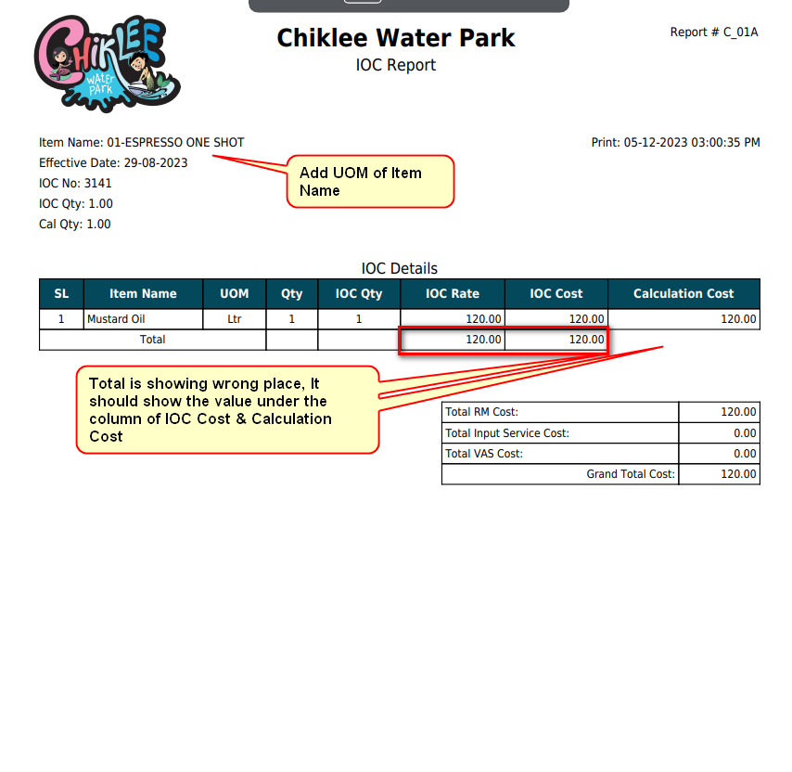

**In UI:**

1. Add more column: 1. IOC UOM, UOM for Every Item, Consumption for IOC & Calculation Cost, IOC Rate etc.
2. IOC Name & Effective Date is not showing

